**Task 18- Real-Time Order Status Tracking System with DynamoDB**

**Amazon DynamoDB** is a fully managed, serverless, key-value and document database designed to run high-performance applications at any scale. It offers automatic scaling and in-memory caching. It supports both eventual and strongly consistent reads, making it well-suited for applications requiring fast, predictable performance with seamless handling of high request volumes. DynamoDB is often used for applications like real-time analytics, gaming, IoT, mobile backends, and more, where low-latency data access and high availability are critical.

**STEP 1- CREATED A TABLE**

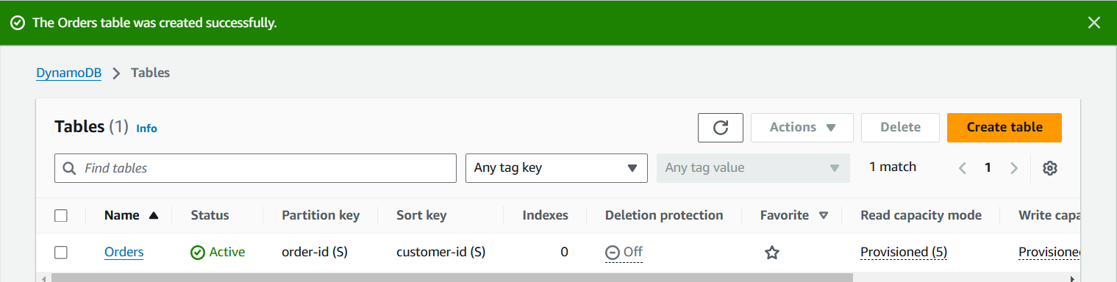

**STEP 2- CREATED AN ITEM**

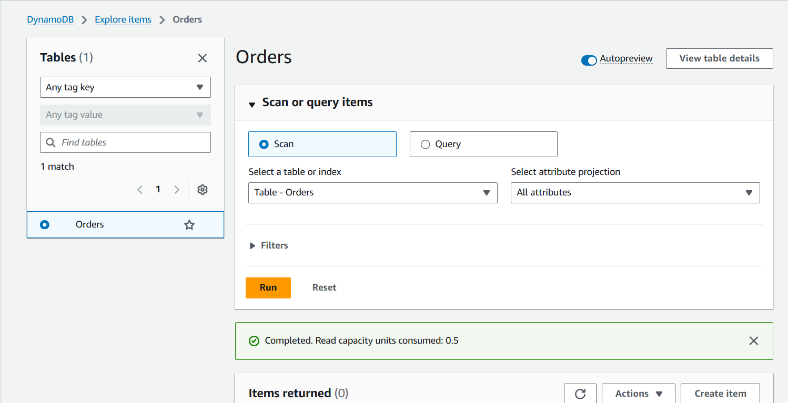

**STEP 3- CREATED AN ITEM BASED ON LOGISTICS**

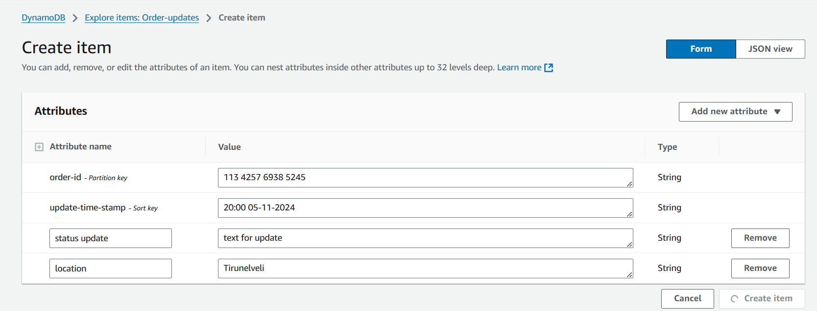

**STEP 4 CREATED ANOTHER ITEM VIA JSON**

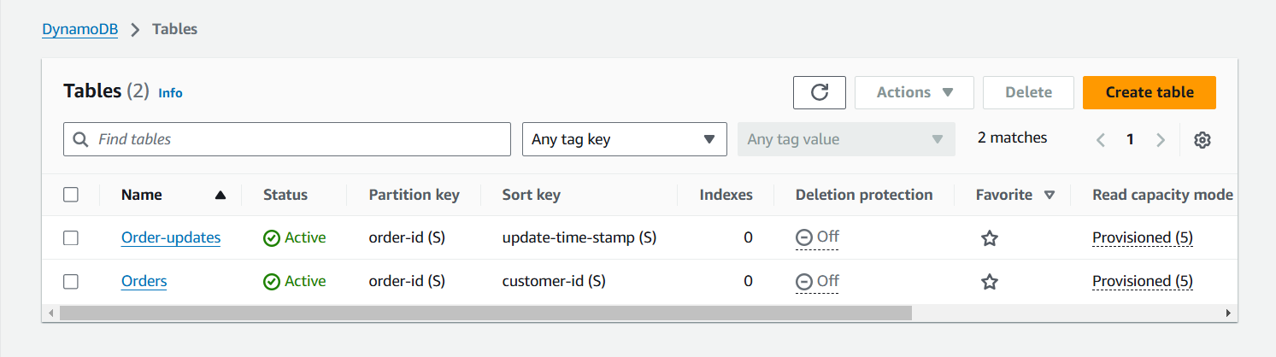

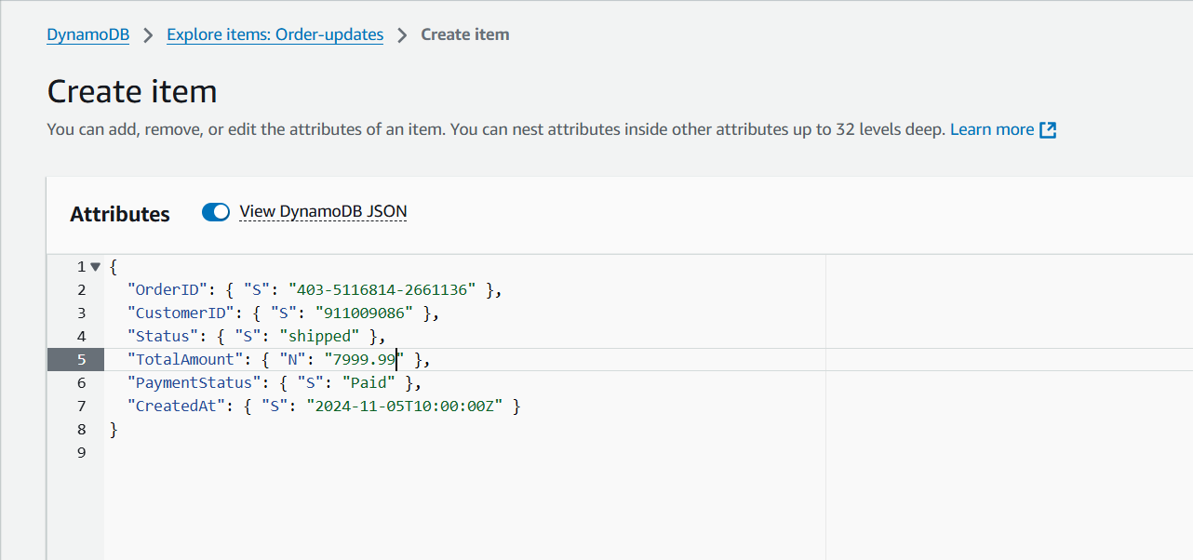

**STEP 5- OUTPUT**

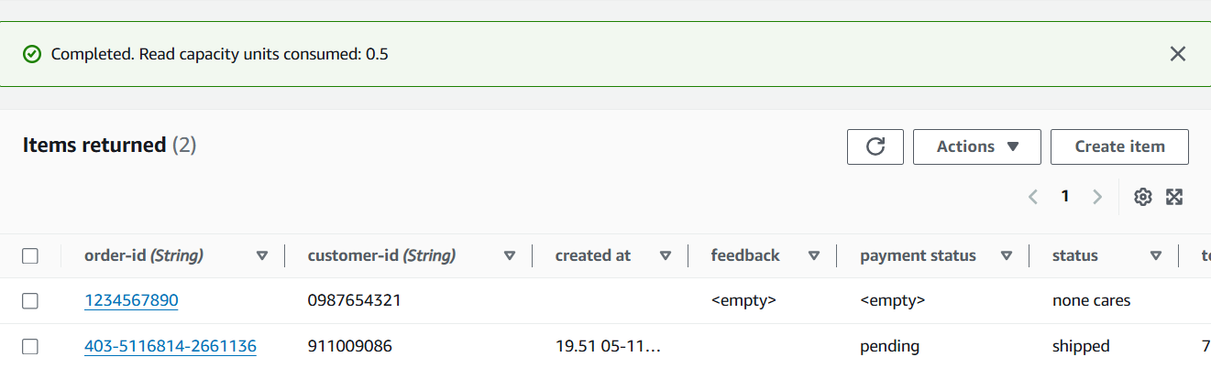

**DynamoDB is optimized for speed and scalability in unstructured data workloads. Unstructured data workloads refer to applications and storage solutions that handle data without a predefined schema. Unlike relational databases (like those in Amazon RDS) that store data in structured tables with fixed columns and data types, unstructured data workloads manage information that may not fit neatly into rows and columns, such as text documents, images, logs, or JSON documents. These workloads typically use NoSQL databases or object storage systems.**

**STEP 6- DELETED TABLES SUCCESSFULLY.**

